**WIMFluence/Response Comparison Scripts User Manual**

Developed for the Arkansas Department of Transportation

TRC1701 — Bridge Load Posting Based on Actual Arkansas Truck Traffic

Program, Scripts, and Manual authored by Kenny Pasley

under the guidance of the project principal investigator, Ernie Heymsfield, Ph.D., P.E.

Copyright © 2016-2018 Kenneth Pasley  
  
Permission is granted to copy, distribute and/or modify this document under the terms of the GNU Free Documentation License, Version 1.3 or any later version published by the Free Software Foundation; with no Invariant Sections, no Front-Cover Texts, and no Back-Cover Texts.  A copy of the license is included in the section entitled "GNU Free Documentation License".

Table of Contents

Introduction 1

Python Installation and Setup 2

Step 1: WIMFluence.exe 3

Output 3

Input 5

Operation 5

Step 2: vs_ArDOT.py / vs_AASHTO.py 7

Output 7

Input 9

Operation 9

Step 3: vs_ArDOT_combined.py / vs_AASHTO_combined.py / AASHTO_vs_ArDOT_combined.py 9

Output 10

Input 11

Operation 11

Step 4: concise_table_vs_ArDOT.py / concise_table_vs_AASHTO.py / concise_table_AASHTO_vs_ArDOT.py 12

Output 12

Input 13

Operation 13

GNU Free Documentation License 15

Appendix 23

# Introduction

This manual aims to comprehensively explain the operation of, inputs for, and outputs of the program and scripts developed for TRC1701. The flowchart below gives an overview of the operation steps involved. The installation of Python and the necessary modules follows this introduction. Each main operation step has its own explanation section afterward. An appendix of code requirements finishes the manual.

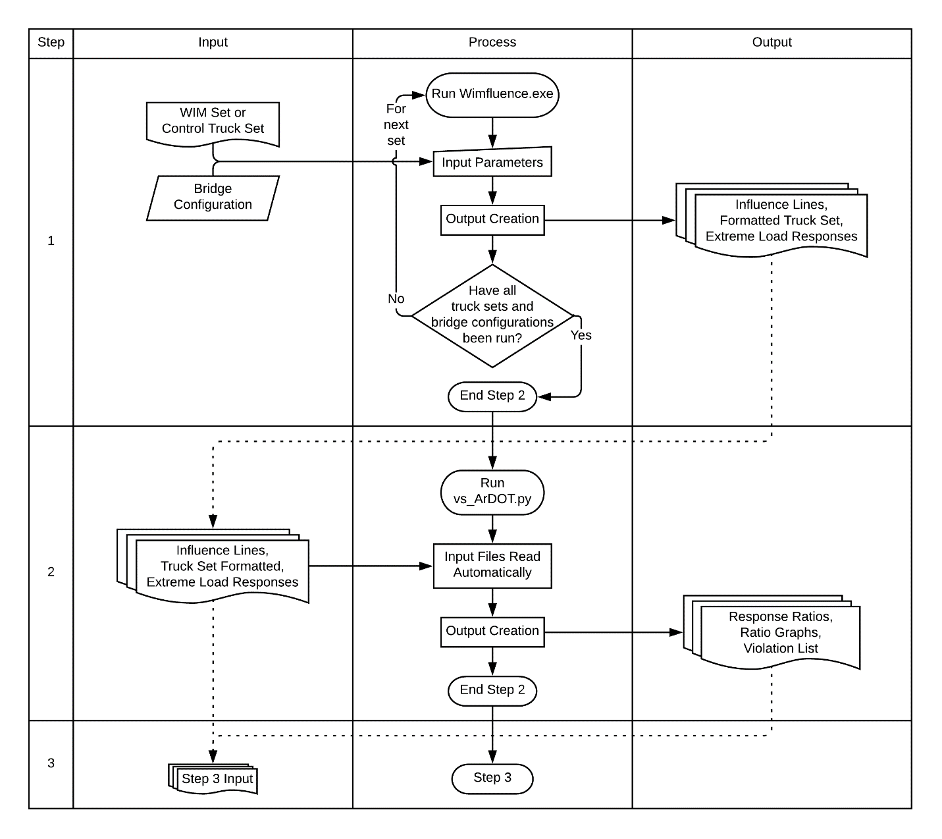

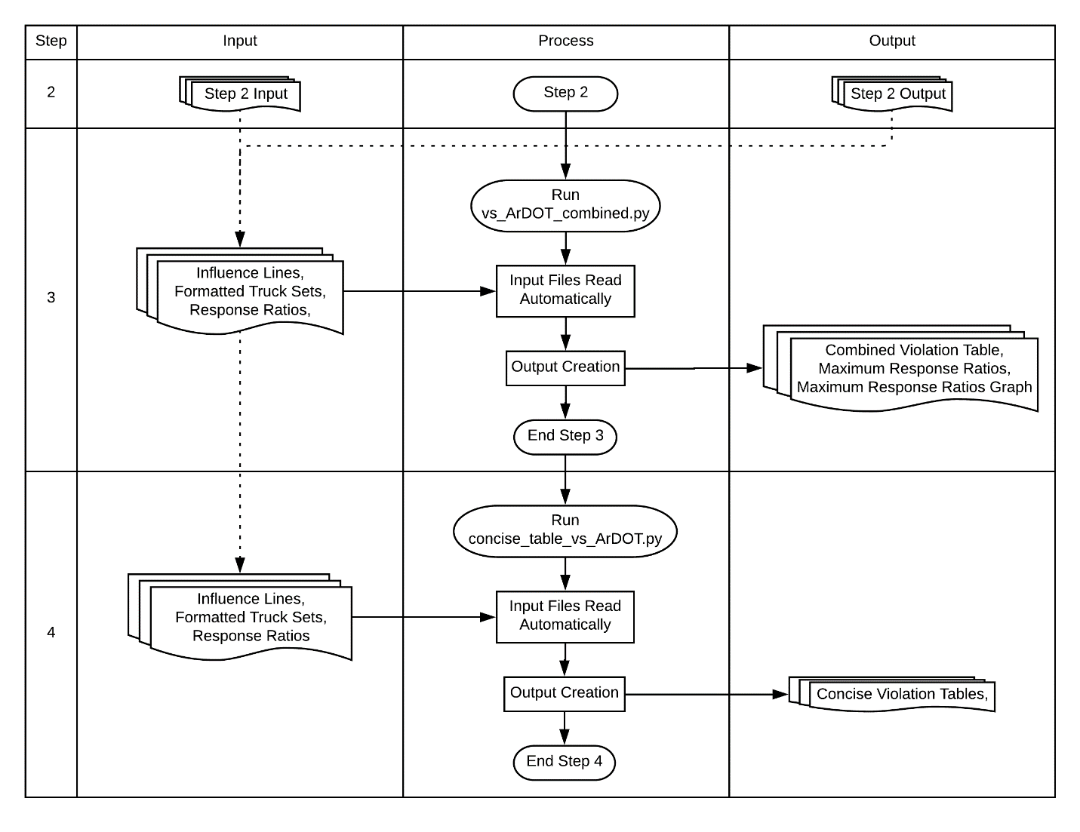

# Python Installation and Setup

These scripts are created for use with the Anaconda distribution of Python. Navigate to the web address below in an internet browser. From there, download the Anaconda Windows installer for Python 3.X. Run the installer and follow the installation dialog box to install.

https://www.anaconda.com/download/

If these scripts are the only things Python is needed for, Anaconda includes more than is necessary. In that case installing Python and each necessary module independently may be preferential. If inexperienced in such things, the excess overhead of Anaconda can be worthwhile if trying to avoid potential headaches of installing each piece independently. Based on this and the scripts being written for Anaconda, use of the Anaconda distribution is the recommended method for Python installation.

To uninstall Anaconda, follow the instructions presented at the website below.

https://docs.anaconda.com/anaconda/install/uninstall

If the Python scripts do not run after double clicking, the .py file extension may need to be associated with Python. Note that the exact wording of the selections in these instructions may vary depending on the Windows version. Right click a script file, select “Open with,” then select “Choose another app.” From the dialog box that opens, select Python. If multiple Python entries are available, select the one with an icon appearing to represent a program window. The other entry should appear to represent a sheet of paper. Now check the box for “Always use this app to open .py files.” If neither entry is available or these steps do not work, additional help may be found on the internet. Alternatively, the python scripts can still be run via command line as described in the “Operation” subsection of each script section.

# Step 1: WIMFluence.exe

Description:

This code reads a file of truck configurations to find the maximum positive moment, negative moment, and shear values at analysis points along a given bridge configuration. The analysis points are spaced at 20ths within each span of the bridge.

## Output

Within the following file names, “CLASS” is replaced with the appropriate class name and “BRIDGE” is replaced with a description of the bridge on which the response values are for.

Output files are contained in a folder describing the bridge configuration within the “output” folder.

* **IL_BRIDGE.csv**: This includes the influence lines for the moment of, shear at the left of, and shear at the right of each analysis point. Analysis points are given as both actual values and ratios to the length of the first span. Influence factors are in terms of the length of the first span.
  + *spans*: the number of spans in the bridge configuration
  + *span lengths*: the lengths (ft) of each span in order from left to right
  + *span length ratios*: the ratios of span length to first span length in order from left to right
  + *internal support positions*: the position (ft) of internal supports in order from left to right
  + *internal support position ratios*: the ratios of support positions first span length in order from left to right
  + *analysis_point*: the location at which the response factors are determined
  + *analysis_point_ratio*: the ratio of the *analysis_point* to the length of the first span
  + *load_point*: the location of the point load causing the responses at *analysis_point*
  + *moment*: the moment response value in terms of point load value (*P*) at *load_point* and first span length (*L1*). Multiply this value by *P* and *L1* to find the actual moment response value.
  + *left_shear*: the shear value at the left side of *analysis_point* in terms of the point load value (*P*) at *load_point*. Multiply this value by *P* to find the actual shear response at the left side
  + *right_shear*: the shear value at the right side of *analysis_point* in terms of the point load value (*P*) at *load_point*. Multiply this value by *P* to find the actual shear response at the right side
* **CLASS_formatted.csv**: This is an alternative format list of the trucks given in the truck input file. This format is potentially friendlier for database-like tools. Depending on the size of the input truck file, this file can easily exceed the row limit of a Microsoft Excel spreadsheet.
  + *truck_index*: the number *n* meaning the *n*th truck in the set
  + *num_axles*: the number of axles on the truck
  + *axle_num*: the number *n* meaning the *n*th axle of the truck
  + *axle_weight*: the weight (kips) of the axle defined by *axle_num* and *truck_index*
  + *axle_rel_pos*: the relative position in feet of the axle defined by *axle_num* and *truck_index* to the first axle of the truck defined by *truck_index*. The negative value indicates the axle being behind the first axle. A value of -5 means the axle is 5 feet behind the first axle.
* **CLASS_extreme_response_BRIDGE.csv**: This gives the maximum and minimum values for moment, left shear, and right shear at each analysis point. The "NaN" values are simply placeholders to allow a script that used this file to run properly. There are six rows per analysis point — a minimum and maximum value for each of the three responses.
  + *truck_index*: the truck number producing the extreme response value within the same row. This corresponds with the truck index given in the alternative format truck file.
  + *truck_direction*: the direction the truck is facing to produce the extreme response. "f" denotes a truck traveling forward along the bridge (left to right) and "b" denotes a truck traveling backward (right to left).
  + *first_axle_pos*: the position in feet of the front (steering) axle of the truck along the bridge. A forward-facing truck will have other axles to the left of the steering axle while a backward-facing truck will have other axles to the right. A negative value means the first axle is off the bridge to the left of it (before it). This occurs in conjunction with a backwards facing truck resulting in at least the rear axle being on the bridge.
  + *analysis_point*: the location in feet at which the extreme response value is being found on the bridge.
  + *moment*: the extreme moment (kip-ft) values at each analysis point. These are the maximum and minimum moment values. In the case of no negative moment values, the minimum value will be zero.
  + *shear_left*: the extreme shear (kip) values at the left side of the analysis point. These are the maximum and minimum left shear values.
  + *shear_right*: the extreme shear (kip) values at the right side of the analysis point. These are the maximum and minimum right shear values.

## Input

* Truck set (WIM)1 file within folder “input” with file extension of “.txt” or “.csv”
* The name of the file before the period is used as the name of the truck set in subsequent files.
  + The first line is a header line that is ignored by the code. This can contain anything the user desires, such as column names or truck set descriptions
  + Subsequent lines detail individual trucks. The first value in the line shall be the number of axles on the truck. The following value is the weight (kips) of the first axle. Following those are the alternating axle spaces (ft) and axle weights (kips) in order from front to back. Axle spaces shall be integer values. Anything on the line after the last axle weight is ignored by the code, so truck labels can be placed there if desired. Labels can be left off if so desired. Spaces shall separate values. Any other delimiter will cause the code to fail. The following example lines detail the AASHTO SU5 truck and ArDOT Code 4.

5 12 10 8 4 8 4 17 4 17 AASHTO SU5

3 11 8 20 4 14 ArDOT Code 4

## Operation

With the input files in the “input” folder, run the executable (run via double click, command line, etc.). Follow the prompt that follows.

* Input the name of the truck set file to be ran. (Ex. “ArDOT.txt”, “Class_7.csv”)
* Tell whether the truck file is in metric (“y”) or not (“n”). If the file is in metric units, then the axle spaces and weights describe in the Inputs section shall be in decimeters and 100 kilograms (0.1 tonne). Metric units will be converted to kips and nearest foot values.
* Input the number of spans
* Input the length (ft) of each span. Span lengths shall be in integer feet values.

The program then creates the “output” folder and the subfolder describing the bridge configuration.

The folder location is given in the command line interface and the output file names are shown. A description of the bridge configuration is given followed by the run time of the code.

Repeat this process for each input file and bridge configuration desired.

The program can be run quickly at the command line by echoing the input parameters in order then piping that into the program execution. Example:

(echo ArDOT.txt n 2 30 20) | WIMFluence.exe

The PowerShell equivalent is given below.

"ArDOT.txt n 2 30 40" | ./ WIMFluence.exe

In the two examples above, the truck input file is given followed by the yes or no for metric units, the number of spans, and the lengths of each span. That information is then piped into the input text stream of the program execution.

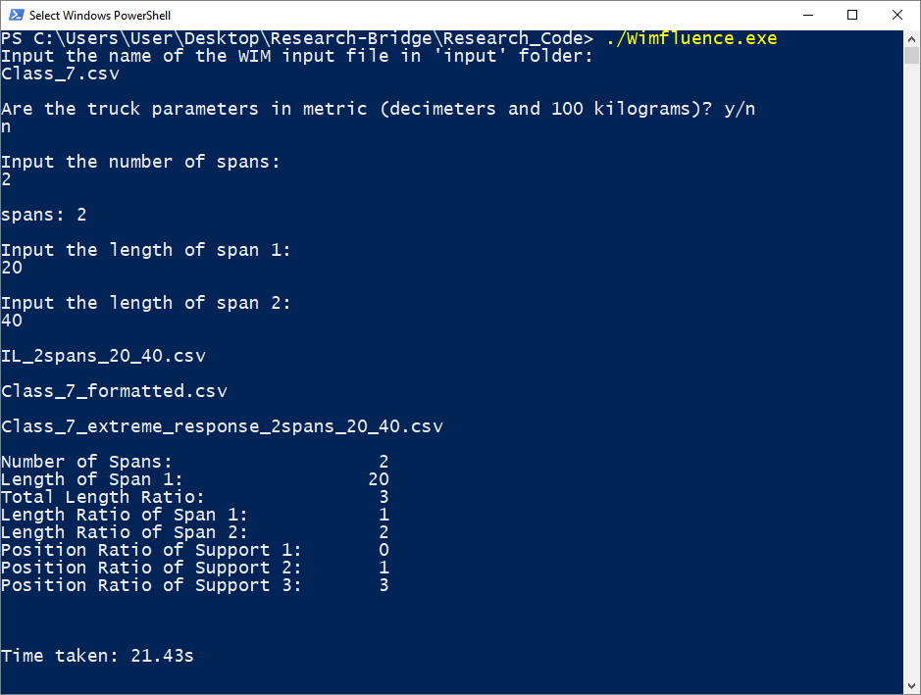

# Steps 2-4: Data Analysis Python Scripts

The Python scripts are written for the Anaconda distribution of Python 3. The use of Anaconda is recommended, but the modules can be installed individually if so desired.

These require truck set files have been named “Class_#.csv” or “Class_#.txt” when run through the above program. Either control truck set (ArDOT or AASHTO) must have also been already run.

These scripts should be placed within the “output” folder produced by the above code. They are listed in the order to be run.

# Step 2: vs_ArDOT.py / vs_AASHTO.py

Python Modules: os, winsound, numpy, pandas, matplotlib, timeit

Description: This script walks through the folders within “output” to find response ratios for each truck class compared to the control truck set (ArDOT or AASHTO). Files are created detailing the response ratios for shear, positive moment, and negative moment; the corresponding response values; and the trucks creating those response values.

## Output

Within the following file names, “#” is replaced with the appropriate class number, “CONTROL” is replaced with either “ArDOT” or “AASHTO” for whichever is used as a control, and “BRIDGE” is replaced with a description of the bridge on which the response values are for.

The following four files are within the bridge-specific folder within the “output” folder.

* **ratios_moment_neg_Class_#_vs_CONTROL_BRIDGE.csv**: gives the negative moment ratios for each analysis point as well as the moment and trucks creating them.
* **ratios_moment_pos_Class_#_vs_CONTROL_BRIDGE.csv**: gives the positive moment ratios for each analysis point as well as the moment and trucks creating them.
* **ratios_shear_Class_#_vs_CONTROL_BRIDGE.csv**: gives the shear ratios for each analysis point as well as the shear and trucks creating them.
* The following columns are the same for the three previously described files. “RESPONSE” should be replaced with the corresponding response type (moment_neg, moment_pos, shear)
  + *analysis_point*: the location (ft) along the bridge at which the response ratio occurs
  + *span_position*: the location of the analysis point within its bridge span. The integer part tells which support is left of the analysis point. The fractional part tells how far within the span the analysis point occurs. In “0.35”, the “0” indicates the external support is to the left of the analysis point. The “.35” indicates the analysis point is 35% of the way through the span. “2.85” indicates 85% through the third bridge span. “2.00” indicates the end of the second span and the beginning of the third.
  + *ratio_moment_neg_max*: the ratio of the negative moment values of the truck class to the control set. “max” refers to the response values being the extreme ones produced by the truck set when run through the previous program.
  + *Class_#_RESPONSE_max*: the response value in class *#* producing the corresponding ratio
  + *CONTROL_RESPONSE_max*: the response value in the control set producing the corresponding ratio
  + *Class_#_truck_index*: the truck number of class *#* producing the corresponding response value
  + *Class_#_truck_direction*: the direction the class *#* truck is facing to produce the corresponding response value. "f" denotes a truck traveling forward along the bridge (left to right) and "b" denotes a truck traveling backward (right to left).
  + *Class_#_first_axle_pos*: the location (ft) of the first axle of the class *#* truck to produce corresponding response value. A forward-facing truck will have other axles to the left of the steering axle while a backward-facing truck will have other axles to the right. A negative value means the first axle is off the bridge to the left of it (before it). This occurs in conjunction with a backwards facing truck resulting in at least the rear axle being on the bridge.
  + *CONTROL_truck_index*: the truck number of the control set producing the corresponding response value
  + *CONTROL_truck_direction*: the direction the control set truck is facing to produce the corresponding response value. "f" denotes a truck traveling forward along the bridge (left to right) and "b" denotes a truck traveling backward (right to left).
  + *CONTROL_first_axle_pos*: the location (ft) of the first axle of the control set truck to produce corresponding response value. A forward-facing truck will have other axles to the left of the steering axle while a backward-facing truck will have other axles to the right. A negative value means the first axle is off the bridge to the left of it (before it). This occurs in conjunction with a backwards facing truck resulting in at least the rear axle being on the bridge.
* **Class_#_vs_CONTROL_BRIDGE.png**: a graph of the three response ratios for each analysis point along the bridge. The positive moment is not graphed near the supports due to small moment values creating large ratios (e.g. 0.1 kips / 0.01kips = 10).

The following file is within the “output” folder.

* **violation_list_vs_CONTROL.csv**: a list of bridge configuration and class combinations and whether a ratio exceeds 1 or not
  + *span_configuration*: description of the bridge span for which the response ratios are found
  + *class*: the truck class for which the response ratios are found
  + *mom_pos_max_ratio*: the maximum positive moment ratio produced by *class* in *span_configuration*
  + *mom_pos_position*: the location (ft) within the bridge at which the positive moment ratio occurs
  + *mom_pos_span_position*: the position within the span at which the positive moment ratio occurs. The integer indicates the support to the left of the position (0 being the left external support). The decimal indicates how far into the span the point is (.35 being 35% into the span).
  + *mom_neg_max_ratio*: the maximum negative moment ratio produced by *class* in *span_configuration*
  + *mom_neg_position*: the location (ft) within the bridge at which the negative moment ratio occurs
  + *mom_neg_span_position*: the position within the span at which the negative moment ratio occurs. The integer indicates the support to the left of the position (0 being the left external support). The decimal indicates how far into the span the point is (.35 being 35% into the span).
  + *shear_max_ratio*: the maximum shear ratio produced by *class* in *span_configuration*
  + *shear_position*: the location (ft) within the bridge at which the shear ratio occurs
  + *shear_span_position*: the position within the span at which the shear ratio occurs. The integer indicates the support to the left of the position (0 being the left external support). The decimal indicates how far into the span the point is (.35 being 35% into the span).
  + *violation*: boolean value telling whether a response ratio greater than 1 occurs or not

## Input

The inputs for this script are the outputs of the previous program. Files are already in their proper locations.

## Operation

Ensure Python and the necessary modules are installed first. See the Python installation section for more information.

Double click the script file to run it in the current directory. The script is open in a new command prompt window. This window will close after script execution.

If preferred, the script can be run via Command Prompt or PowerShell. Right click in the folder window the script is in then click “Open command window here” or “Open PowerShell window here.” Type “**python vs_ArDOT.py**” or “**python vs_AASHTO.py**” then press Enter. This method will run the script within the current window and keep the window open after execution.

During execution, the window will display the current folder it is walking through. With knowledge of the bridge configurations present, this output can be used to measure the script’s progress. At the end, the duration of the run is reported in seconds.

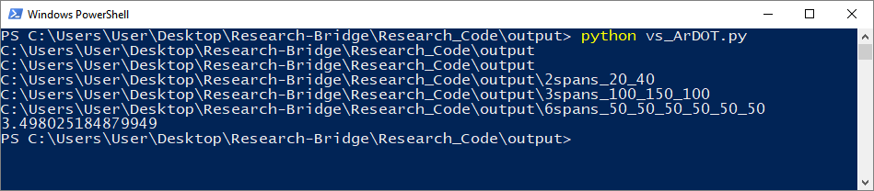

# Step 3: vs_ArDOT_combined.py / vs_AASHTO_combined.py / AASHTO_vs_ArDOT_combined.py

Python Modules: os, winsound, numpy, pandas, matplotlib, timeit, sys

Description: This script takes the response ratios produced by the previous script and combines them across all truck classes for each bridge configuration. The maximum response ratio among all truck classes is found for each analysis point. This allows one to focus on the response ratio behavior of specific bridge configurations regardless of which truck class produces the response ratios. The truck class producing each maximum response ratio is reported in the output files to track which classes consistently produce the greatest responses.

**AASHTO_vs_ArDOT_combined.py** does not combine the response ratios of different truck classes like the other two do. It still produces each of the output files produced by the other two, so its inclusion in this section is appropriate.

## Output

Within the following names, “CONTROL” is replaced with either “ArDOT” or “AASHTO” for whichever is used as a control, “BRIDGE” is replaced with a description of the bridge on which the response values are for, and “RESPONSE” is replaced with the corresponding response type (moment_pos, moment_neg, shear or moment_positive, moment_negative, shear).

For **AASHTO_vs_ArDOT_Combined.py**, “All” is replaced with “AASHTO” to reflect the script’s nature.

* **All_vs_CONTROL_RESPONSE_violation_table.csv**: This table shows problem response ratios and their corresponding truck class in a format somewhat reminiscent of the bridge configurations represented. It can be viewed as a text-based alternative to the response ratio figures also produced for each bridge configuration. This table has the benefit of showing all bridge configurations in a single file and reporting only the response ratios exceeding 1.
  + The first row is the span position of the response ratio reported. Span position refers to the fractional location of a position within its span of the bridge. The integer portion represents the support index (0 being the initial external support or leftmost support). The decimal portion is the percentage within the span at which the location occurs (ex. .35 indicates 35% within the span).
  + The first column gives the bridge configuration represented in each row. The numbers after “spans” gives the span lengths (ft) from left to right.
  + The rest of the table is the response ratios occurring at each span position for each bridge configuration. Ratios not greater than 1 are represented by “—” instead of being reported explicitly. This allows one to quickly pick out the issue response ratios across all bridge configurations and span positions. “N/A” is reported near each bridge support in the positive moment table. Ratios near the supports are neglected due to extreme ratios being produced by small moment values.

The following files are bridge-specific.

* **ratios_RESPONSE_All_vs_CONTROL_BRIDGE.csv**: the greatest response ratios at each analysis point across all truck classes
  + *analysis_point*: the location (ft) into the bridge at which the response ratio occurs
  + *span_position*: the position within the span at which the response ratio occurs. The integer indicates the support to the left of the position (0 being the left external support). The decimal indicates how far into the span the point is (.35 being 35% into the span).
  + *ratio_RESPONSE_max*: the greatest response ratio occurring at the analysis point across all truck classes
  + *class_RESPONSE_max*: the extreme response value of a class truck producing the response ratio
  + *CONTROL_RESPONSE_max*: the extreme response value of the control set truck producing the response ratio
  + *class_truck_index*: the truck number of the class truck producing the response ratio
  + *class_truck_direction*: the direction the class truck is facing to produce the response value. “f” denotes a truck facing forward (or to the right) along the bridge. “b” denotes a truck facing backward (or to the left) along the bridge.
  + *class_first_axle_pos*: the position (ft) onto the bridge of the first axle of the class truck to produce the response value. A negative value indicates the first axle is off the bridge and before (or to the left) of it.
  + *CONTROL_truck_index*: the truck number of the control set truck producing the response ratio
  + *CONTROL _truck_direction*: the direction the control set truck is facing to produce the response value. “f” denotes a truck facing forward (or to the right) along the bridge. “b” denotes a truck facing backward (or to the left) along the bridge.
  + *CONTROL _first_axle_pos*: the position (ft) onto the bridge of the first axle of the control set truck to produce the response value. A negative value indicates the first axle is off the bridge and before ( or to the left) of it.
  + *truck_class*: the truck class of the truck producing the response value
* **ratios_RESPONSE_All_vs_CONTROL_BRIDGE.png**: A graphical representation of the contents of the previous file. The truck class producing each response ratio is reported toward the top of the figure.

## Input

The inputs for this script are the outputs of the previous program and script. Files are already in their proper locations.

## Operation

Ensure Python and the necessary modules are installed first. See the Python installation section for more information.

Double click the script file to run it in the current directory. The script is open in a new command prompt window. This window will close after script execution.

If preferred, the script can be run via Command Prompt or PowerShell. Right click in the folder window the script is in then click “Open command window here” or “Open PowerShell window here.” Type “python” and the script name separated with a space. Press Enter. This method will run the script within the current window and keep the window open after execution.

During execution, the window will display the base name of the current folder it is walking through. The period in the first line of output represents the parent directory of the script. As this is the first folder the script walks through, it is reported along with all the bridge-specific folders. The use of a period to represent the current folder path is a shorthand convention. With knowledge of the bridge configurations present, this output can be used to measure the script’s progress.

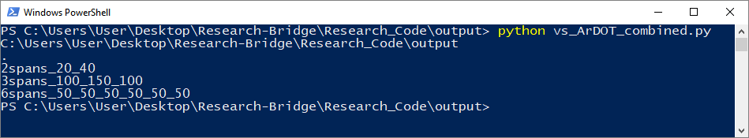

# Step 4: concise_table_vs_ArDOT.py / concise_table_vs_AASHTO.py / concise_table_AASHTO_vs_ArDOT.py

Python Modules: os, winsound, pandas

Description: This script takes the response ratios produced by the first script and combines them across all truck classes for each bridge configuration. The maximum response ratio among all truck classes is found for each analysis point. This allows one to focus on the response ratio behavior of specific bridge configurations regardless of which truck class produces the response ratios. The truck class producing each maximum response ratio is reported in the output files to track which classes consistently produce the greatest responses. This script differs from the previous script in the format of the response ratio table.

**concise_table_AASHTO_vs_ArDOT.py** does not combine the response ratios across classes. It produces the same output table for only AASHTO compared to ArDOT.

This script will crash if it finds that there are no instances of response ratios greater than 1.

## Output

* **RESPONSE_violation_vs_CONTROL_ordered_table.csv**: This gives the response ratios greater than 1 for each bridge configuration and reports other information for each ratio. It is sorted from greatest response ratio to least.
  + *ratio_RESPONSE*: the ratio of the greatest response produced by a truck class to the control truck set
  + *bridge_span*: a description of the bridge configuration on which the response ratio occurs
  + *truck_class*: the truck class producing the response ratio. This column is nonexistent for the output of **AASHTO_vs_ArDOT_combined.py** as the column contents would always be “AASHTO.”
  + *analysis_point*: the location (ft) into the bridge at which the response ratio occurs
  + *span_position*: the position within the span at which the response ratio occurs. The integer indicates the support to the left of the position (0 being the left external support). The decimal indicates how far into the span the point is (.35 being 35% into the span).
  + *class_truck*: a description of the class truck producing the response ratio. Values preceding the dash are the lengths (ft) of the axle spaces from front to back. Values after the dash are the axle weights (kips) from front to back. For the output of **AASHTO_vs_ArDOT_combined.py**, this column is named *AASHTO_truck* and gives the name of the truck instead of a description of it.
  + *gross_weight*: the gross weight (kips) of the class truck producing the response ratio. This column is omitted in the output of **AASHTO_vs_ArDOT_combined.py**.
  + *total_length*: the total length (ft) of the class truck producing the response ratio. This column is omitted in the output of **AASHTO_vs_ArDOT_combined.py**.
  + *CONTROL_truck*: the name of the control set truck producing the response ratio.
  + *class_RESPONSE*: the actual response value producing the response ratio. Moment is in kip-ft and shear is in kips. This column is renamed *AASHTO_RESPONSE* in the output of **AASHTO_vs_ArDOT_combined.py**.
  + *CONTROL_RESPONSE*: the actual response value from the control set producing the response ratio

## Input

The inputs for this script are the outputs of the previous program and scripts. Files are already in their proper locations provided the previous program and scripts have been run.

## Operation

Ensure Python and the necessary modules are installed first. See the Python installation section for more information.

Double click the script file to run it in the current directory. The script is open in a new command prompt window. This window will close after script execution.

If preferred, the script can be run via Command Prompt or PowerShell. Right click in the folder window the script is in then click “Open command window here” or “Open PowerShell window here.” Type “python” and the script name separated with a space. Press Enter. This method will run the script within the current window and keep the window open after execution.

During execution, the window will display the base name of the current folder it is walking through and the class truck set it is importing. The period in the first line of output represents the parent directory of the script. As this is the first folder the script walks through, it is reported along with all the bridge-specific folders. The use of a period to represent the current folder path is a shorthand convention. Class truck sets are imported once then kept in memory for the duration of the script run. Class truck sets are thus only reported after the first bridge configuration in which they are encountered. With knowledge of the bridge configurations and truck classes present, this output can be used to measure the script’s progress.

### GNU Free Documentation License

Version 1.3, 3 November 2008

Copyright (C) 2000, 2001, 2002, 2007, 2008 Free Software Foundation, Inc.

<https://fsf.org/>

Everyone is permitted to copy and distribute verbatim copies

of this license document, but changing it is not allowed.

0. PREAMBLE

The purpose of this License is to make a manual, textbook, or other

functional and useful document "free" in the sense of freedom: to

assure everyone the effective freedom to copy and redistribute it,

with or without modifying it, either commercially or noncommercially.

Secondarily, this License preserves for the author and publisher a way

to get credit for their work, while not being considered responsible

for modifications made by others.

This License is a kind of "copyleft", which means that derivative

works of the document must themselves be free in the same sense. It

complements the GNU General Public License, which is a copyleft

license designed for free software.

We have designed this License in order to use it for manuals for free

software, because free software needs free documentation: a free

program should come with manuals providing the same freedoms that the

software does. But this License is not limited to software manuals;

it can be used for any textual work, regardless of subject matter or

whether it is published as a printed book. We recommend this License

principally for works whose purpose is instruction or reference.

1. APPLICABILITY AND DEFINITIONS

This License applies to any manual or other work, in any medium, that

contains a notice placed by the copyright holder saying it can be

distributed under the terms of this License. Such a notice grants a

world-wide, royalty-free license, unlimited in duration, to use that

work under the conditions stated herein. The "Document", below,

refers to any such manual or work. Any member of the public is a

licensee, and is addressed as "you". You accept the license if you

copy, modify or distribute the work in a way requiring permission

under copyright law.

A "Modified Version" of the Document means any work containing the

Document or a portion of it, either copied verbatim, or with

modifications and/or translated into another language.

A "Secondary Section" is a named appendix or a front-matter section of

the Document that deals exclusively with the relationship of the

publishers or authors of the Document to the Document's overall

subject (or to related matters) and contains nothing that could fall

directly within that overall subject. (Thus, if the Document is in

part a textbook of mathematics, a Secondary Section may not explain

any mathematics.) The relationship could be a matter of historical

connection with the subject or with related matters, or of legal,

commercial, philosophical, ethical or political position regarding

them.

The "Invariant Sections" are certain Secondary Sections whose titles

are designated, as being those of Invariant Sections, in the notice

that says that the Document is released under this License. If a

section does not fit the above definition of Secondary then it is not

allowed to be designated as Invariant. The Document may contain zero

Invariant Sections. If the Document does not identify any Invariant

Sections then there are none.

The "Cover Texts" are certain short passages of text that are listed,

as Front-Cover Texts or Back-Cover Texts, in the notice that says that

the Document is released under this License. A Front-Cover Text may

be at most 5 words, and a Back-Cover Text may be at most 25 words.

A "Transparent" copy of the Document means a machine-readable copy,

represented in a format whose specification is available to the

general public, that is suitable for revising the document

straightforwardly with generic text editors or (for images composed of

pixels) generic paint programs or (for drawings) some widely available

drawing editor, and that is suitable for input to text formatters or

for automatic translation to a variety of formats suitable for input

to text formatters. A copy made in an otherwise Transparent file

format whose markup, or absence of markup, has been arranged to thwart

or discourage subsequent modification by readers is not Transparent.

An image format is not Transparent if used for any substantial amount

of text. A copy that is not "Transparent" is called "Opaque".

Examples of suitable formats for Transparent copies include plain

ASCII without markup, Texinfo input format, LaTeX input format, SGML

or XML using a publicly available DTD, and standard-conforming simple

HTML, PostScript or PDF designed for human modification. Examples of

transparent image formats include PNG, XCF and JPG. Opaque formats

include proprietary formats that can be read and edited only by

proprietary word processors, SGML or XML for which the DTD and/or

processing tools are not generally available, and the

machine-generated HTML, PostScript or PDF produced by some word

processors for output purposes only.

The "Title Page" means, for a printed book, the title page itself,

plus such following pages as are needed to hold, legibly, the material

this License requires to appear in the title page. For works in

formats which do not have any title page as such, "Title Page" means

the text near the most prominent appearance of the work's title,

preceding the beginning of the body of the text.

The "publisher" means any person or entity that distributes copies of

the Document to the public.

A section "Entitled XYZ" means a named subunit of the Document whose

title either is precisely XYZ or contains XYZ in parentheses following

text that translates XYZ in another language. (Here XYZ stands for a

specific section name mentioned below, such as "Acknowledgements",

"Dedications", "Endorsements", or "History".) To "Preserve the Title"

of such a section when you modify the Document means that it remains a

section "Entitled XYZ" according to this definition.

The Document may include Warranty Disclaimers next to the notice which

states that this License applies to the Document. These Warranty

Disclaimers are considered to be included by reference in this

License, but only as regards disclaiming warranties: any other

implication that these Warranty Disclaimers may have is void and has

no effect on the meaning of this License.

2. VERBATIM COPYING

You may copy and distribute the Document in any medium, either

commercially or noncommercially, provided that this License, the

copyright notices, and the license notice saying this License applies

to the Document are reproduced in all copies, and that you add no

other conditions whatsoever to those of this License. You may not use

technical measures to obstruct or control the reading or further

copying of the copies you make or distribute. However, you may accept

compensation in exchange for copies. If you distribute a large enough

number of copies you must also follow the conditions in section 3.

You may also lend copies, under the same conditions stated above, and

you may publicly display copies.

3. COPYING IN QUANTITY

If you publish printed copies (or copies in media that commonly have

printed covers) of the Document, numbering more than 100, and the

Document's license notice requires Cover Texts, you must enclose the

copies in covers that carry, clearly and legibly, all these Cover

Texts: Front-Cover Texts on the front cover, and Back-Cover Texts on

the back cover. Both covers must also clearly and legibly identify

you as the publisher of these copies. The front cover must present

the full title with all words of the title equally prominent and

visible. You may add other material on the covers in addition.

Copying with changes limited to the covers, as long as they preserve

the title of the Document and satisfy these conditions, can be treated

as verbatim copying in other respects.

If the required texts for either cover are too voluminous to fit

legibly, you should put the first ones listed (as many as fit

reasonably) on the actual cover, and continue the rest onto adjacent

pages.

If you publish or distribute Opaque copies of the Document numbering

more than 100, you must either include a machine-readable Transparent

copy along with each Opaque copy, or state in or with each Opaque copy

a computer-network location from which the general network-using

public has access to download using public-standard network protocols

a complete Transparent copy of the Document, free of added material.

If you use the latter option, you must take reasonably prudent steps,

when you begin distribution of Opaque copies in quantity, to ensure

that this Transparent copy will remain thus accessible at the stated

location until at least one year after the last time you distribute an

Opaque copy (directly or through your agents or retailers) of that

edition to the public.

It is requested, but not required, that you contact the authors of the

Document well before redistributing any large number of copies, to

give them a chance to provide you with an updated version of the

Document.

4. MODIFICATIONS

You may copy and distribute a Modified Version of the Document under

the conditions of sections 2 and 3 above, provided that you release

the Modified Version under precisely this License, with the Modified

Version filling the role of the Document, thus licensing distribution

and modification of the Modified Version to whoever possesses a copy

of it. In addition, you must do these things in the Modified Version:

A. Use in the Title Page (and on the covers, if any) a title distinct

from that of the Document, and from those of previous versions

(which should, if there were any, be listed in the History section

of the Document). You may use the same title as a previous version

if the original publisher of that version gives permission.

B. List on the Title Page, as authors, one or more persons or entities

responsible for authorship of the modifications in the Modified

Version, together with at least five of the principal authors of the

Document (all of its principal authors, if it has fewer than five),

unless they release you from this requirement.

C. State on the Title page the name of the publisher of the

Modified Version, as the publisher.

D. Preserve all the copyright notices of the Document.

E. Add an appropriate copyright notice for your modifications

adjacent to the other copyright notices.

F. Include, immediately after the copyright notices, a license notice

giving the public permission to use the Modified Version under the

terms of this License, in the form shown in the Addendum below.

G. Preserve in that license notice the full lists of Invariant Sections

and required Cover Texts given in the Document's license notice.

H. Include an unaltered copy of this License.

I. Preserve the section Entitled "History", Preserve its Title, and add

to it an item stating at least the title, year, new authors, and

publisher of the Modified Version as given on the Title Page. If

there is no section Entitled "History" in the Document, create one

stating the title, year, authors, and publisher of the Document as

given on its Title Page, then add an item describing the Modified

Version as stated in the previous sentence.

J. Preserve the network location, if any, given in the Document for

public access to a Transparent copy of the Document, and likewise

the network locations given in the Document for previous versions

it was based on. These may be placed in the "History" section.

You may omit a network location for a work that was published at

least four years before the Document itself, or if the original

publisher of the version it refers to gives permission.

K. For any section Entitled "Acknowledgements" or "Dedications",

Preserve the Title of the section, and preserve in the section all

the substance and tone of each of the contributor acknowledgements

and/or dedications given therein.

L. Preserve all the Invariant Sections of the Document,

unaltered in their text and in their titles. Section numbers

or the equivalent are not considered part of the section titles.

M. Delete any section Entitled "Endorsements". Such a section

may not be included in the Modified Version.

N. Do not retitle any existing section to be Entitled "Endorsements"

or to conflict in title with any Invariant Section.

O. Preserve any Warranty Disclaimers.

If the Modified Version includes new front-matter sections or

appendices that qualify as Secondary Sections and contain no material

copied from the Document, you may at your option designate some or all

of these sections as invariant. To do this, add their titles to the

list of Invariant Sections in the Modified Version's license notice.

These titles must be distinct from any other section titles.

You may add a section Entitled "Endorsements", provided it contains

nothing but endorsements of your Modified Version by various

parties--for example, statements of peer review or that the text has

been approved by an organization as the authoritative definition of a

standard.

You may add a passage of up to five words as a Front-Cover Text, and a

passage of up to 25 words as a Back-Cover Text, to the end of the list

of Cover Texts in the Modified Version. Only one passage of

Front-Cover Text and one of Back-Cover Text may be added by (or

through arrangements made by) any one entity. If the Document already

includes a cover text for the same cover, previously added by you or

by arrangement made by the same entity you are acting on behalf of,

you may not add another; but you may replace the old one, on explicit

permission from the previous publisher that added the old one.

The author(s) and publisher(s) of the Document do not by this License

give permission to use their names for publicity for or to assert or

imply endorsement of any Modified Version.

5. COMBINING DOCUMENTS

You may combine the Document with other documents released under this

License, under the terms defined in section 4 above for modified

versions, provided that you include in the combination all of the

Invariant Sections of all of the original documents, unmodified, and

list them all as Invariant Sections of your combined work in its

license notice, and that you preserve all their Warranty Disclaimers.

The combined work need only contain one copy of this License, and

multiple identical Invariant Sections may be replaced with a single

copy. If there are multiple Invariant Sections with the same name but

different contents, make the title of each such section unique by

adding at the end of it, in parentheses, the name of the original

author or publisher of that section if known, or else a unique number.

Make the same adjustment to the section titles in the list of

Invariant Sections in the license notice of the combined work.

In the combination, you must combine any sections Entitled "History"

in the various original documents, forming one section Entitled

"History"; likewise combine any sections Entitled "Acknowledgements",

and any sections Entitled "Dedications". You must delete all sections

Entitled "Endorsements".

6. COLLECTIONS OF DOCUMENTS

You may make a collection consisting of the Document and other

documents released under this License, and replace the individual

copies of this License in the various documents with a single copy

that is included in the collection, provided that you follow the rules

of this License for verbatim copying of each of the documents in all

other respects.

You may extract a single document from such a collection, and

distribute it individually under this License, provided you insert a

copy of this License into the extracted document, and follow this

License in all other respects regarding verbatim copying of that

document.

7. AGGREGATION WITH INDEPENDENT WORKS

A compilation of the Document or its derivatives with other separate

and independent documents or works, in or on a volume of a storage or

distribution medium, is called an "aggregate" if the copyright

resulting from the compilation is not used to limit the legal rights

of the compilation's users beyond what the individual works permit.

When the Document is included in an aggregate, this License does not

apply to the other works in the aggregate which are not themselves

derivative works of the Document.

If the Cover Text requirement of section 3 is applicable to these

copies of the Document, then if the Document is less than one half of

the entire aggregate, the Document's Cover Texts may be placed on

covers that bracket the Document within the aggregate, or the

electronic equivalent of covers if the Document is in electronic form.

Otherwise they must appear on printed covers that bracket the whole

aggregate.

8. TRANSLATION

Translation is considered a kind of modification, so you may

distribute translations of the Document under the terms of section 4.

Replacing Invariant Sections with translations requires special

permission from their copyright holders, but you may include

translations of some or all Invariant Sections in addition to the

original versions of these Invariant Sections. You may include a

translation of this License, and all the license notices in the

Document, and any Warranty Disclaimers, provided that you also include

the original English version of this License and the original versions

of those notices and disclaimers. In case of a disagreement between

the translation and the original version of this License or a notice

or disclaimer, the original version will prevail.

If a section in the Document is Entitled "Acknowledgements",

"Dedications", or "History", the requirement (section 4) to Preserve

its Title (section 1) will typically require changing the actual

title.

9. TERMINATION

You may not copy, modify, sublicense, or distribute the Document

except as expressly provided under this License. Any attempt

otherwise to copy, modify, sublicense, or distribute it is void, and

will automatically terminate your rights under this License.

However, if you cease all violation of this License, then your license

from a particular copyright holder is reinstated (a) provisionally,

unless and until the copyright holder explicitly and finally

terminates your license, and (b) permanently, if the copyright holder

fails to notify you of the violation by some reasonable means prior to

60 days after the cessation.

Moreover, your license from a particular copyright holder is

reinstated permanently if the copyright holder notifies you of the

violation by some reasonable means, this is the first time you have

received notice of violation of this License (for any work) from that

copyright holder, and you cure the violation prior to 30 days after

your receipt of the notice.

Termination of your rights under this section does not terminate the

licenses of parties who have received copies or rights from you under

this License. If your rights have been terminated and not permanently

reinstated, receipt of a copy of some or all of the same material does

not give you any rights to use it.

10. FUTURE REVISIONS OF THIS LICENSE

The Free Software Foundation may publish new, revised versions of the

GNU Free Documentation License from time to time. Such new versions

will be similar in spirit to the present version, but may differ in

detail to address new problems or concerns. See

https://www.gnu.org/licenses/.

Each version of the License is given a distinguishing version number.

If the Document specifies that a particular numbered version of this

License "or any later version" applies to it, you have the option of

following the terms and conditions either of that specified version or

of any later version that has been published (not as a draft) by the

Free Software Foundation. If the Document does not specify a version

number of this License, you may choose any version ever published (not

as a draft) by the Free Software Foundation. If the Document

specifies that a proxy can decide which future versions of this

License can be used, that proxy's public statement of acceptance of a

version permanently authorizes you to choose that version for the

Document.

11. RELICENSING

"Massive Multiauthor Collaboration Site" (or "MMC Site") means any

World Wide Web server that publishes copyrightable works and also

provides prominent facilities for anybody to edit those works. A

public wiki that anybody can edit is an example of such a server. A

"Massive Multiauthor Collaboration" (or "MMC") contained in the site

means any set of copyrightable works thus published on the MMC site.

"CC-BY-SA" means the Creative Commons Attribution-Share Alike 3.0

license published by Creative Commons Corporation, a not-for-profit

corporation with a principal place of business in San Francisco,

California, as well as future copyleft versions of that license

published by that same organization.

"Incorporate" means to publish or republish a Document, in whole or in

part, as part of another Document.

An MMC is "eligible for relicensing" if it is licensed under this

License, and if all works that were first published under this License

somewhere other than this MMC, and subsequently incorporated in whole or

in part into the MMC, (1) had no cover texts or invariant sections, and

(2) were thus incorporated prior to November 1, 2008.

The operator of an MMC Site may republish an MMC contained in the site

under CC-BY-SA on the same site at any time before August 1, 2009,

provided the MMC is eligible for relicensing.

ADDENDUM: How to use this License for your documents

To use this License in a document you have written, include a copy of

the License in the document and put the following copyright and

license notices just after the title page:

Copyright (c) YEAR YOUR NAME.

Permission is granted to copy, distribute and/or modify this document

under the terms of the GNU Free Documentation License, Version 1.3

or any later version published by the Free Software Foundation;

with no Invariant Sections, no Front-Cover Texts, and no Back-Cover Texts.

A copy of the license is included in the section entitled "GNU

Free Documentation License".

If you have Invariant Sections, Front-Cover Texts and Back-Cover Texts,

replace the "with...Texts." line with this:

with the Invariant Sections being LIST THEIR TITLES, with the

Front-Cover Texts being LIST, and with the Back-Cover Texts being LIST.

If you have Invariant Sections without Cover Texts, or some other

combination of the three, merge those two alternatives to suit the

situation.

If your document contains nontrivial examples of program code, we

recommend releasing these examples in parallel under your choice of

free software license, such as the GNU General Public License,

to permit their use in free software.

# Appendix

* The research program requires C++11. It may work with newer C++ standards, but that is untested.
* The research program is compiled using the GNU GCC compiler for C++11 with the following compilation flags
  + -std=c++11
  + -fexpensive-optimizations
  + -O3
* The Python scripts are written for Python 3.6.2 using Anaconda 4.3.29
* Python modules and versions:
  + os
  + matplotlib — 2.0.2
  + numpy — 1.13.1
  + pandas — 0.20.3
  + sys
  + timeit
  + winsound